Team Meeting Log
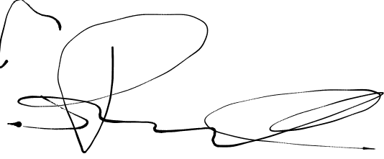  Group 3 | Meeting Log #3 | 2/3/2021 | 30 Minutes
Team Members | Dane Manley | GUI | 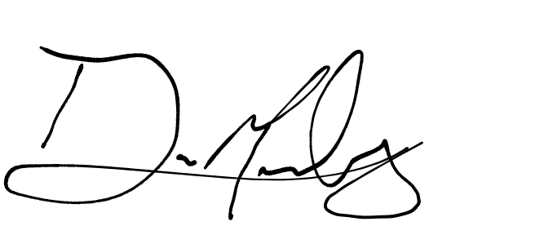
Team Members | Santiago Ramirez | IO, Load/Store
Team Members | Daniel Espinel | Branch, Code Optimization | 
Team Members | Anthony Peterson | Arithmetic | AP
Topics Discussed |  | - IDE used  - Potential issues  - Last minute backlog checking  - Execution Mode GUI layout
Obstacles Encountered |  | - Needed IDE shift from VS
Finished Items |  | - Branch Ops  - GUI Skeleton  - Editing Mode
Unfinished Items |  | - Other Operations  - Memory Dump
Notes

